EXPERIMENT – 9

Name : Vansh gupta

Batch – 4

Sap Id - 500123239

- Write a Java program that reads a file name from the user and attempts to open and read the file. Define a method readFile() that throws a FileNotFoundException using the throws keyword. In the main method, call this method and handle the exception using a try-catch block. Display an appropriate message if the file is not found. Use a finally block to ensure a message like "File operation attempted" is printed.

import java.io.File;
import java.io.FileNotFoundException;
import java.util.Scanner;

public class FileReaderExample {

public static void readFile(String fileName) throws FileNotFoundException {
File file = new File(fileName);
Scanner scanner = new Scanner(file);

System.out.println("File contents:");
while (scanner.hasNextLine()) {
System.out.println(scanner.nextLine());
}
scanner.close();
}

public static void main(String[] args) {
Scanner input = new Scanner(System.in);
System.out.print("Enter the file name: ");
String fileName = input.nextLine();

try {
readFile(fileName);
} catch (FileNotFoundException e) {
System.out.println("Error: File not found!");
} finally {
System.out.println("File operation attempted.");
}

input.close();
}
}
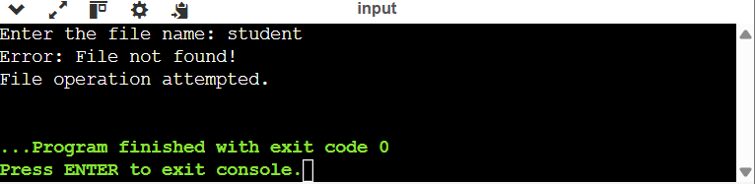

- Write a Java program that takes user input for a student's name, roll number, and grade, and writes this information to a file named student.txt using FileWriter. Ensure the program appends the data to the file if it already exists. Handle any exceptions using try-catch and display an appropriate message if an error occurs.
Sample File Content:
Name: Aman, Roll Number: 120112, Grade: A
Name: Parul, Roll Number: 120131, Grade: B

import java.io.FileWriter;
import java.io.IOException;
import java.util.Scanner;

public class StudentRecordWriter {
public static void main(String[] args) {
Scanner input = new Scanner(System.in);

// Taking student details as input
System.out.print("Enter student's name: ");
String name = input.nextLine();

System.out.print("Enter roll number: ");
String rollNumber = input.nextLine();

System.out.print("Enter grade: ");
String grade = input.nextLine();

// Formatting the data
String studentData = "Name: " + name + ", Roll Number: " + rollNumber + ", Grade: " + grade + "\n";

// Writing to the file
try (FileWriter writer = new FileWriter("student.txt", true)) { // 'true' enables append mode
writer.write(studentData);
System.out.println("Student information successfully written to student.txt");
} catch (IOException e) {
System.out.println("Error: Unable to write to file!");
} finally {
System.out.println("File operation attempted.");
}

input.close();
}
}

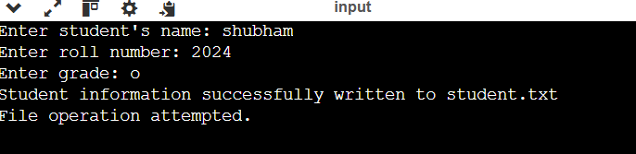

- Write a Java program that reads the contents of a file named student.txt using FileReader and displays the data on the console. Handle FileNotFoundException if the file does not exist and display an appropriate error message. Use a try-catch block for exception handling.

import java.io.FileReader;
import java.io.FileNotFoundException;
import java.io.IOException;

public class StudentRecordReader {
public static void main(String[] args) {
String fileName = "student.txt";

try (FileReader reader = new FileReader(fileName)) {
int character;
System.out.println("File contents:");
while ((character = reader.read()) != -1) {
System.out.print((char) character);
}
System.out.println();
} catch (FileNotFoundException e) {
System.out.println("Error: The file " + fileName + " was not found!");
} catch (IOException e) {
System.out.println("Error: An I/O error occurred while reading the file.");
}
}
}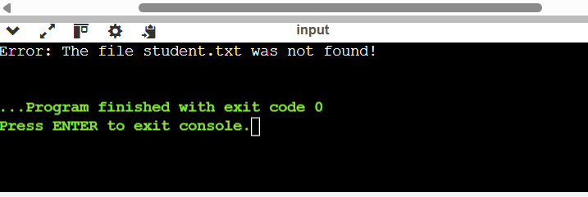

- Write a program that prompts the user for a text file name, opens the file using a FileInputStream (or FileReader), and counts the total number of words and characters (excluding whitespace). Print these counts to the console. Test your program on files with varied content and edge cases (e.g., empty file, file with only whitespace, etc.).

import java.io.FileReader;
import java.io.FileNotFoundException;
import java.io.IOException;
import java.util.Scanner;

public class FileWordCharacterCounter {
public static void main(String[] args) {
Scanner input = new Scanner(System.in);
System.out.print("Enter the file name: ");
String fileName = input.nextLine();

int charCount = 0;
int wordCount = 0;

try (FileReader reader = new FileReader(fileName);
Scanner fileScanner = new Scanner(reader)) {

while (fileScanner.hasNextLine()) {
String line = fileScanner.nextLine();

charCount += line.replaceAll("\\s", "").length();

String[] words = line.trim().split("\\s+");
if (!line.trim().isEmpty()) {
wordCount += words.length;
}
}

System.out.println("Total words: " + wordCount);
System.out.println("Total characters (excluding whitespace): " + charCount);

} catch (FileNotFoundException e) {
System.out.println("Error: The file '" + fileName + "' was not found!");
} catch (IOException e) {
System.out.println("Error: An I/O error occurred while reading the file.");
}

input.close();
}
}

- Write a class Person with fields like name and age, implementing Serializable. In your main method, create an instance of Person and serialize it to a file (person.txt) using ObjectOutputStream. Then, read it back using ObjectInputStream and confirm that the deserialized object has the same field values.

import java.io.*;

class Person implements Serializable {
private static final long serialVersionUID = 1L;
private String name;
private int age;

public Person(String name, int age) {
this.name = name;
this.age = age;
}

@Override
public String toString() {
return "Person{name='" + name + "', age=" + age + "}";
}
}

public class PersonSerializationDemo {
public static void main(String[] args) {
String fileName = "person.txt";

Person person = new Person("shubham", 20);

try (ObjectOutputStream oos = new ObjectOutputStream(new FileOutputStream(fileName))) {
oos.writeObject(person);
System.out.println("Serialization successful: " + person);
} catch (IOException e) {
System.out.println("Error: Unable to serialize object!");
}

try (ObjectInputStream ois = new ObjectInputStream(new FileInputStream(fileName))) {
Person deserializedPerson = (Person) ois.readObject();
System.out.println("Deserialization successful: " + deserializedPerson);
} catch (IOException | ClassNotFoundException e) {
System.out.println("Error: Unable to deserialize object!");
}
}
}

